**SDLC Model Contd..**

3. V-Model: The V-model is an SDLC model where execution of processes happens in a sequential manner in a V-shape. It is also known as **Verification and Validation model**.

**The V-Model is an extension of the waterfall model and is based on the association of a testing phase for each corresponding development stage. This means that for every single phase in the development cycle, there is a directly associated testing phase**. This is a highly-disciplined model and the next phase starts only after completion of the previous phase.

V-Model - Design

Under the V-Model, the corresponding testing phase of the development phase is planned in parallel. So, there are Verification phases on one side of the ‘V’ and Validation phases on the other side. The Coding Phase joins the two sides of the V-Model.

The following illustration depicts the different phases in a V-Model of the SDLC.

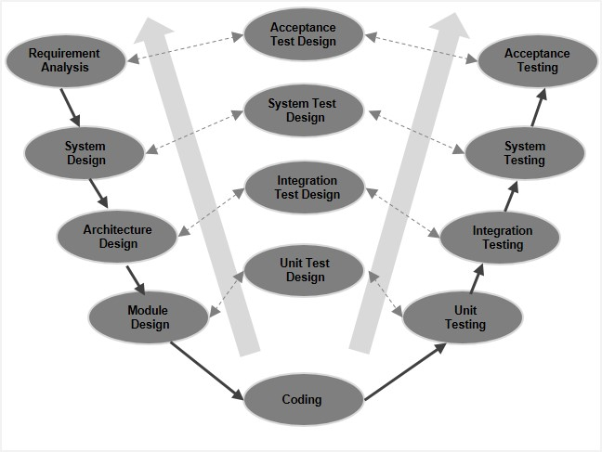

V-Model - Verification Phases

There are several Verification phases in the V-Model, each of these are explained in detail below.

**Business Requirement Analysis**

This is the first phase in the development cycle where the product requirements are understood from the customer’s perspective. This phase involves detailed communication with the customer to understand his expectations and exact requirement. This is a very important activity and needs to be managed well, as most of the customers are not sure about what exactly they need. The **acceptance test design planning** is done at this stage as business requirements can be used as an input for acceptance testing.

**System Design**

Once you have the clear and detailed product requirements, it is time to design the complete system. The system design will have the understanding and detailing the complete hardware and communication setup for the product under development. The system test plan is developed based on the system design. Doing this at an earlier stage leaves more time for the actual test execution later.

**Architectural Design**

Architectural specifications are understood and designed in this phase. Usually more than one technical approach is proposed and based on the technical and financial feasibility the final decision is taken. The system design is broken down further into modules taking up different functionality. This is also referred to as **High Level Design (HLD)**.

The data transfer and communication between the internal modules and with the outside world (other systems) is clearly understood and defined in this stage. With this information, integration tests can be designed and documented during this stage.

**Module Design**

In this phase, the detailed internal design for all the system modules is specified, referred to as **Low Level Design (LLD)**. It is important that the design is compatible with the other modules in the system architecture and the other external systems. The unit tests are an essential part of any development process and helps eliminate the maximum faults and errors at a very early stage. These unit tests can be designed at this stage based on the internal module designs.

Coding Phase

The actual coding of the system modules designed in the design phase is taken up in the Coding phase. The best suitable programming language is decided based on the system and architectural requirements.

The coding is performed based on the coding guidelines and standards. The code goes through numerous code reviews and is optimized for best performance before the final build is checked into the repository.

Validation Phases

The different Validation Phases in a V-Model are explained in detail below.

**Unit Testing**

Unit tests designed in the module design phase are executed on the code during this validation phase. Unit testing is the testing at code level and helps eliminate bugs at an early stage, **though all defects cannot be uncovered by unit testing**.

**Integration Testing**

Integration testing is associated with the architectural design phase. Integration tests are performed to test the coexistence and communication of the internal modules within the system.

**System Testing**

System testing is directly associated with the system design phase. System tests check the entire system functionality and the communication of the system under development with external systems. Most of the software and hardware compatibility issues can be uncovered during this system test execution.

**Acceptance Testing**

Acceptance testing is associated with the business requirement analysis phase and involves testing the product in user environment. Acceptance tests uncover the compatibility issues with the other systems available in the user environment. It also discovers the non-functional issues such as load and performance defects in the actual user environment.

V- Model ─ Application

V- Model application is almost the same as the waterfall model, as both the models are of sequential type. Requirements have to be very clear before the project starts, because it is usually expensive to go back and make changes. This model is used in the medical development field, as it is strictly a disciplined domain.

The following pointers are some of the most suitable scenarios to use the V-Model application.

* Requirements are well defined, clearly documented and fixed.
* Product definition is stable.
* Technology is not dynamic and is well understood by the project team.
* There are no ambiguous or undefined requirements.
* The project is short.

V-Model - Pros and Cons

The advantage of the V-Model method is that it is very easy to understand and apply. The simplicity of this model also makes it easier to manage. The disadvantage is that the model is not flexible to changes and just in case there is a requirement change, which is very common in today’s dynamic world, it becomes very expensive to make the change.

The advantages of the V-Model method are as follows −

* This is a highly-disciplined model and Phases are completed one at a time.
* Works well for smaller projects where requirements are very well understood.
* Simple and easy to understand and use.
* Easy to manage due to the rigidity of the model. Each phase has specific deliverables and a review process.
* Testing starts at an early phase.

The disadvantages of the V-Model method are as follows −

* High risk and uncertainty.
* Not a good model for complex and object-oriented projects.
* Poor model for long and ongoing projects.
* Not suitable for the projects where requirements are at a moderate to high risk of changing.
* Once an application is in the testing stage, it is difficult to go back and change a functionality.
* No working software is produced until late during the life cycle.

4. Spiral Model: The spiral model combines the idea of iterative development with the systematic, controlled aspects of the waterfall model. This Spiral model is a combination of iterative development process model and sequential linear development model i.e. the waterfall model with a very high emphasis on risk analysis. It allows incremental releases of the product or incremental refinement through each iteration around the spiral.

Spiral Model - Design

The spiral model has four phases. A software project repeatedly passes through these phases in iterations called Spirals.

**Identification**

This phase starts with gathering the business requirements in the baseline spiral. In the subsequent spirals as the product matures, identification of system requirements, subsystem requirements and unit requirements are all done in this phase.

This phase also includes understanding the system requirements by continuous communication between the customer and the system analyst. At the end of the spiral, the product is deployed in the identified market.

**Design**

The Design phase starts with the conceptual design in the baseline spiral and involves architectural design, logical design of modules, physical product design and the final design in the subsequent spirals.

**Construct or Build**

The Construct phase refers to production of the actual software product at every spiral. In the baseline spiral, when the product is just thought of and the design is being developed a POC (Proof of Concept) is developed in this phase to get customer feedback.

Then in the subsequent spirals with higher clarity on requirements and design details a working model of the software called build is produced with a version number. These builds are sent to the customer for feedback.

**Evaluation and Risk Analysis**

Risk Analysis includes identifying, estimating and monitoring the technical feasibility and management risks, such as schedule slippage and cost overrun. After testing the build, at the end of first iteration, the customer evaluates the software and provides feedback.

The following illustration is a representation of the Spiral Model, listing the activities in each phase.

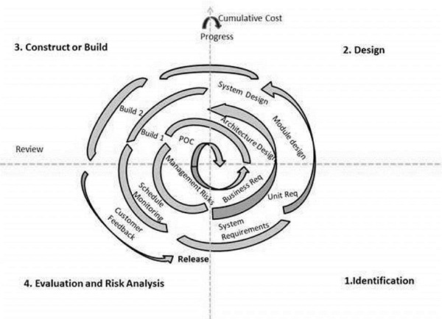

Based on the customer evaluation, the software development process enters the next iteration and subsequently follows the linear approach to implement the feedback suggested by the customer. The process of iterations along the spiral continues throughout the life of the software.

**Spiral Model Application**

The Spiral Model is widely used in the software industry as it is in sync with the natural development process of any product, i.e. learning with maturity which involves minimum risk for the customer as well as the development firms.

The following pointers explain the typical uses of a Spiral Model −

* When there is a budget constraint and risk evaluation is important.
* For medium to high-risk projects.
* Long-term project commitment because of potential changes to economic priorities as the requirements change with time.
* Customer is not sure of their requirements which is usually the case.
* Requirements are complex and need evaluation to get clarity.
* New product line which should be released in phases to get enough customer feedback.
* Significant changes are expected in the product during the development cycle.

Spiral Model - Pros and Cons

The advantage of spiral lifecycle model is that it allows elements of the product to be added in, when they become available or known. This assures that there is no conflict with previous requirements and design.

This method is consistent with approaches that have multiple software builds and releases which allows making an orderly transition to a maintenance activity. Another positive aspect of this method is that the spiral model forces an early user involvement in the system development effort.

On the other side, it takes a very strict management to complete such products and there is a risk of running the spiral in an indefinite loop. So, the discipline of change and the extent of taking change requests is very important to develop and deploy the product successfully.

The advantages of the Spiral SDLC Model are as follows −

* Changing requirements can be accommodated.
* Allows extensive use of prototypes.
* Requirements can be captured more accurately.
* Users see the system early.
* Development can be divided into smaller parts and the risky parts can be developed earlier which helps in better risk management.

The disadvantages of the Spiral SDLC Model are as follows −

* Management is more complex.
* End of the project may not be known early.
* Not suitable for small or low risk projects and could be expensive for small projects.
* Process is complex
* Spiral may go on indefinitely.
* Large number of intermediate stages requires excessive documentation.

5. Agile: AGILE methodology is a practice that promotes **continuous iteration** of development and testing throughout the software development lifecycle of the project. In the Agile model, both development and testing activities are concurrent, unlike the Waterfall model.

The agile software development emphasizes on four core values.

1. Individual and team interactions over processes and tools
2. Working software over comprehensive documentation
3. Customer collaboration over contract negotiation
4. Responding to change over following a plan

There are different methods in Agile which are generally termed as:

:SCRUM  
:Xtreme Programming

**SCRUM** is an agile development method which concentrates specifically on how to manage tasks within a team-based development environment. Basically, Scrum is derived from activity that occurs during a rugby match. Scrum believes in empowering the development team and advocates working in small teams (say- 7 to 9 members). It consists of three roles, and their responsibilities are explained as follows:

[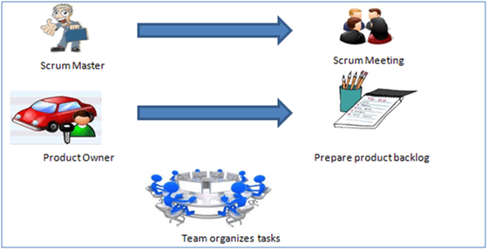](https://www.guru99.com/images/11-2014/agile_Processesv1_3.png)

* Scrum Master
  + Master is responsible for setting up the team, sprint meeting and removes obstacles to progress
* Product owner
  + The Product Owner creates product backlog, prioritizes the backlog and is responsible for the delivery of the functionality at each iteration
* Scrum Team
  + Team manages its own work and organizes the work to complete the sprint or cycle

**Product Backlog**

This is a repository where requirements are tracked with details on the no of requirements(user stories) to be completed for each release. It should be maintained and prioritized by Product Owner, and it should be distributed to the scrum team. Team can also request for a new requirement addition or modification or deletion

**Process flow of Scrum Methodologies:**

Process flow of scrum testing is as follows:

* Each iteration of a scrum is known as Sprint.
* Product backlog is a list where all details are entered to get the end-product.
* During each Sprint, top user stories of Product backlog are selected and turned into Sprint backlog.
* Team works on the defined sprint backlog.
* Team checks for the daily work.
* At the end of the sprint, team delivers product functionality.

**Extreme Programming (XP)**

Extreme Programming technique is very helpful when there is constantly changing demands or requirements from the customers or when they are not sure about the functionality of the system. It advocates frequent "releases" of the product in short development cycles, which inherently improves the productivity of the system and also introduces a checkpoint where any customer requirements can be easily implemented. The XP develops software keeping customer in the target.

[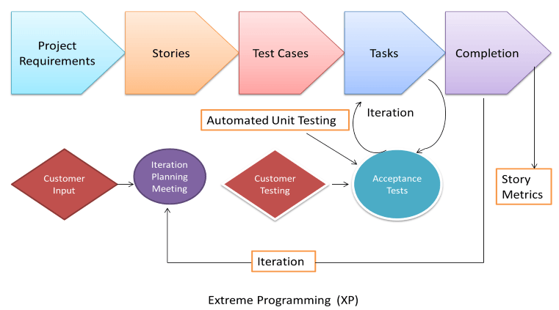](https://www.guru99.com/images/11-2014/agile_Processesv1_5.png)

Business requirements are gathered in terms of stories. All those stories are stored in a place called the parking lot.

In this type of methodology, releases are based on the shorter cycles called Iterations with span of 14 days time period. Each iteration includes phases like coding, unit testing and system testing where at each phase some minor or major functionality will be built in the application.

**Phases of Extreme programming:**

There are 6 phases available in Agile XP method, and those are explained as follows:

***Planning***

* Identification of stakeholders and sponsors
* Infrastructure Requirements
* Security related information and gathering
* Service Level Agreements and its conditions

***Analysis***

* Capturing of Stories in Parking lot
* Prioritize stories in Parking lot
* Scrubbing of stories for estimation
* Define Iteration SPAN(Time)
* Resource planning for both Development and QA teams

***Design***

* Break down of tasks
* Test Scenario preparation for each task
* Regression Automation Framework

***Execution***

* Coding
* Unit Testing
* Execution of Manual test scenarios
* Defect Report generation
* Conversion of Manual to Automation regression test cases
* Mid Iteration review
* End of Iteration review

***Wrapping***

* Small Releases
* Regression Testing
* Demos and reviews
* Develop new stories based on the need
* Process Improvements based on end of iteration review comments

***Closure***

* Pilot Launch
* Training
* Production Launch
* SLA Guarantee assurance
* Production Support

There are two storyboards available to track the work on a daily basis, and those are listed below for reference.

* Story Cardboard
  + This is a traditional way of collecting all the stories in a board in the form of stick notes to track daily XP activities. As this manual activity involves more effort and time, it is better to switch to an online form.
* Online Storyboard
  + Online tool Storyboard can be used to store the stories. **Several teams can use it** for different purposes.